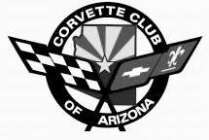
Welcome

Welcome to the Corvette Club of Arizona - Corvettes in the Park Car Show.
We hope you enjoy participating in the Car Show and enjoy viewing all of the great Corvettes.

The Participant’s Choice winners and a Best of Show award will be determined through the voting of the Car Show participants.

Your Car Show Schedule shows today’s general schedule, and supersedes previous flyers & schedules.

We will be selling raffle tickets ($1 each or 6 for $5) for a 50/50 Cash Drawing which will take place at the end of the day. 50% of the proceeds go to the winner, and 50% of the proceeds go to Packages From Home. Get your tickets now and don’t miss out!

We’d like to thank: our sponsor Earnhardt Chevrolet, the City of Chandler for this ideal location, and the merchants affiliated with the Downtown Chandler Community Partnership.

We welcome your opinion and comments in an effort to improve the quality of our show. Please send your feedback to the event chair, Mark Godina.

We’d like to thank you for joining us today.

Corvette Club of Arizona

Mark Godina, Event Chair
480-888-0540
mark.godina93@yahoo.com

